# File permissions in Linux

## Project description

The research team at my organization needs to update the file permissions for certain files and directories within the projects directory. The permissions do not currently reflect the level of authorization that should be given. Checking and updating these permissions will help keep their system secure. To complete this task, I performed the following tasks:

## Check file and directory details

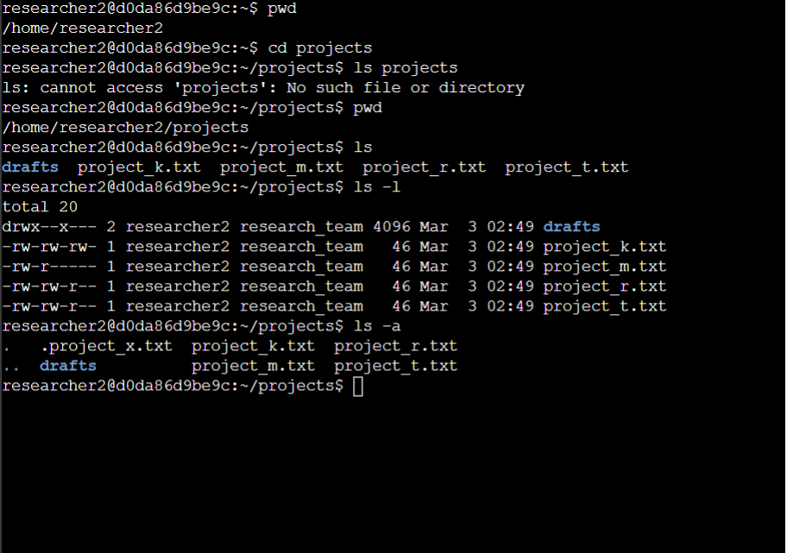

## Describe the permissions string

The permission string for the draft directory is:

* **drwx - - x - - -**

d - this is a directory

**rwx** : the user has read, write and execute permissions.

**- - x** : the group only has the execute permission.

**- - -** : others have no permissions.

## Change file permissions

The organization determined that other shouldn't have write access to any of their files. They also determined that group should not have read access to project_m.txt. The following code demonstrates how I used Linux commands to do this:

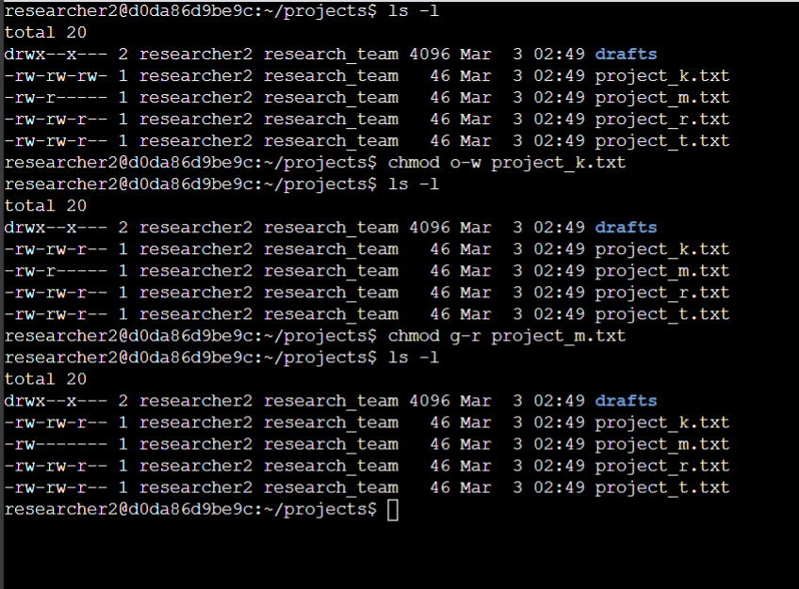

## Change file permissions on a hidden file

The research team does not want anyone to have write access to project_x.txt but the user and group should have read access. The following code demonstrates how I used Linux commands to change the permissions:

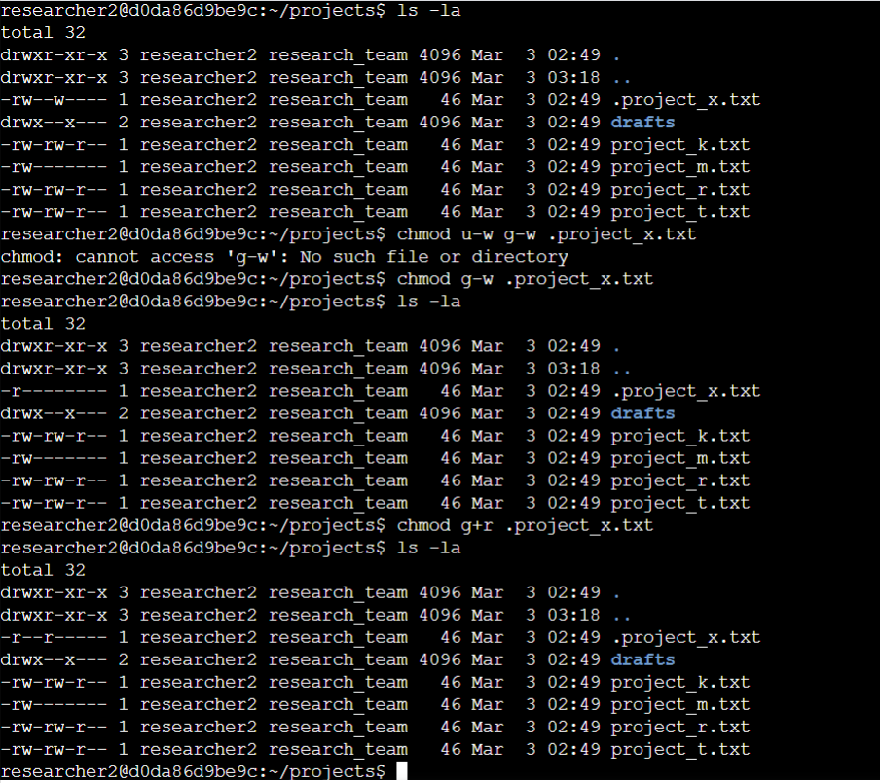

## Change directory permissions

My organization only wants the researcher2 user to have access to the drafts directory and its contents. The following code demonstrates how I used Linux commands to change the permissions:

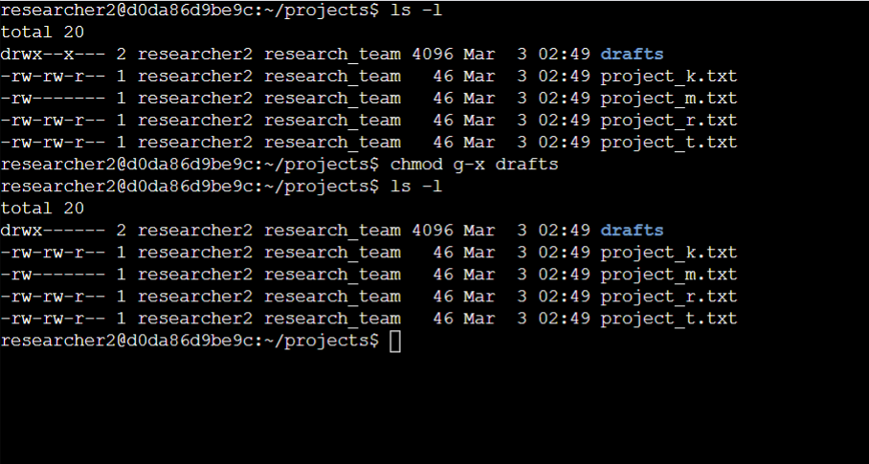

## Summary

I changed multiple permissions to match the level of authorization my organization wanted for files and directories in the projects directory. This involved checking the permissions for the directories and then I used the chmod command multiple times to change the permissions on files and directories.